We rent bikes at Rental Bike shop near Kyoto Station, if the weather is fine. We can rent these types of bikes, but they are not new. ( Kyoto is very strict about illegal parking. We can not allowed to park bikes on the public roads.)

#1 Electric Assisted Bike
- Need additional fee: 1000 yen
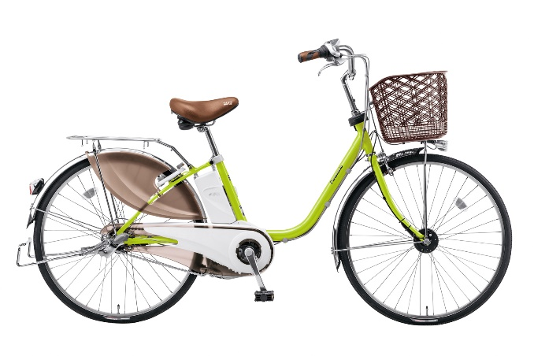
- Need reservation at least one week before.

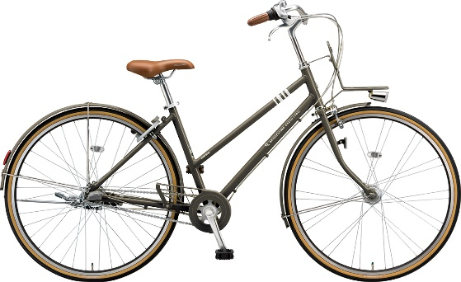
#2 Regular bikes
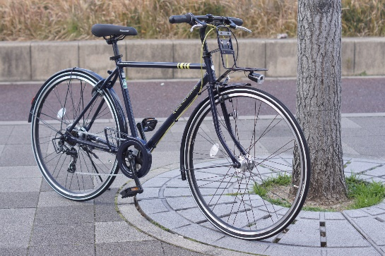

#3 Kids bikes
